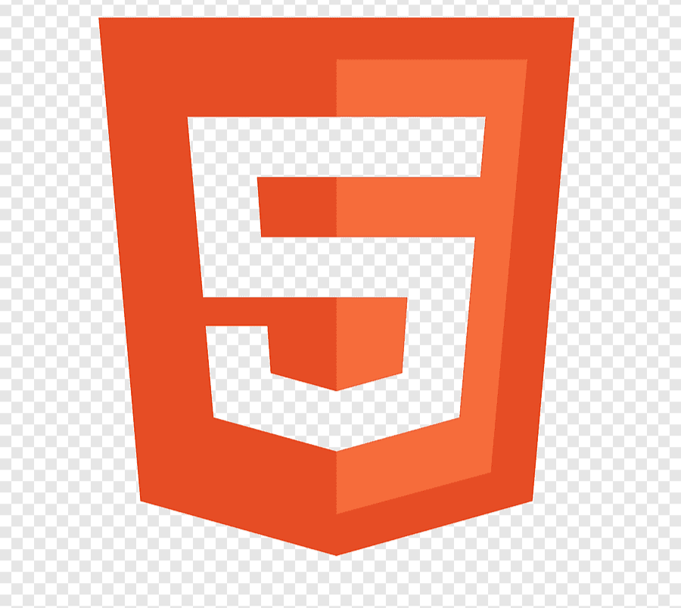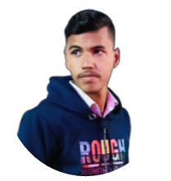

https://ak-portfoliowebsite20.netlify.app/

FULLSTACK WEB DEVELOPER

PYTHON

HTML

Adobe Photoshop

Music

Hiking

Cricket

Javascript

CSS 3

Adobe Illustrator

Basiclly I create only five plus web sites only for practice in

Hand. But also create website like resuma and basic use web site

**HI, I’M Anish kumar a web developer.**

**I'm learning Computer Science & Engineering (CSE).**

**I'M a learner. I learnt frontend-development from Udemy.**

**LANGUAGES**

Hindi

English

+91 637875767007

Anishkumar231999@gmail.com

ANISH

**KUMAR**

**MY SKILLS**

**EXPERIENCE**

I have basic experience of freelancing. But I nerver work on large projects I created only basic uses website only.

**Basice experience of freelancing**

Web developer on freelancer

**Web development**

Web development

**ABOUT ME**

**HOBBIES**

**EDUCATION**

Reading

I basically learn from offline for first time in collage interenship how create a website and deploy.

**Web Wevelopment first interenship** (2022)

Codesession acadmey

I learnt complet HTML, Css & JavaScript from udemy .

I got certificate for that course . and I have basice experience of developing a web site from that course.

**Fronted Web Development** (2021)

Udemy.